High level Briefing for councillors re the plans for the Edmonton Incinerator – Capacity
This is part of a series of briefing papers for decision makers covering Capacity, Emissions and Costs and Ownership with recommendations to reassess the aspects of the plan that have been subject to change. S Charles 25/07/21

Introduction
There have been significant policy and technology changes since the new incinerator proposals were originally formulated. These include: demand versus forecast capacity /recycling policies/ waste separation technology/ low carbon polices and new technologies. There is a window of opportunity to adjust to these changes to future-proof the cost effectiveness, viability and sustainability of North London waste handling.

Scene Setting
The plan was approved by the Planning Inspectorate in 2017 for the redevelopment of the Edmonton site to serve the seven North London Boroughs who jointly own NLWA and its assets. NLWA commissioned the North London Heat and Power Project (NLHPP) to deliver the transformation of the site, concluding with an Energy Recovery Facility, also known as Energy from Waste (EfW) with an incinerator capacity of 700,000 tonnes of waste, due to be contracted by early 2022 and commissioned by 2027.
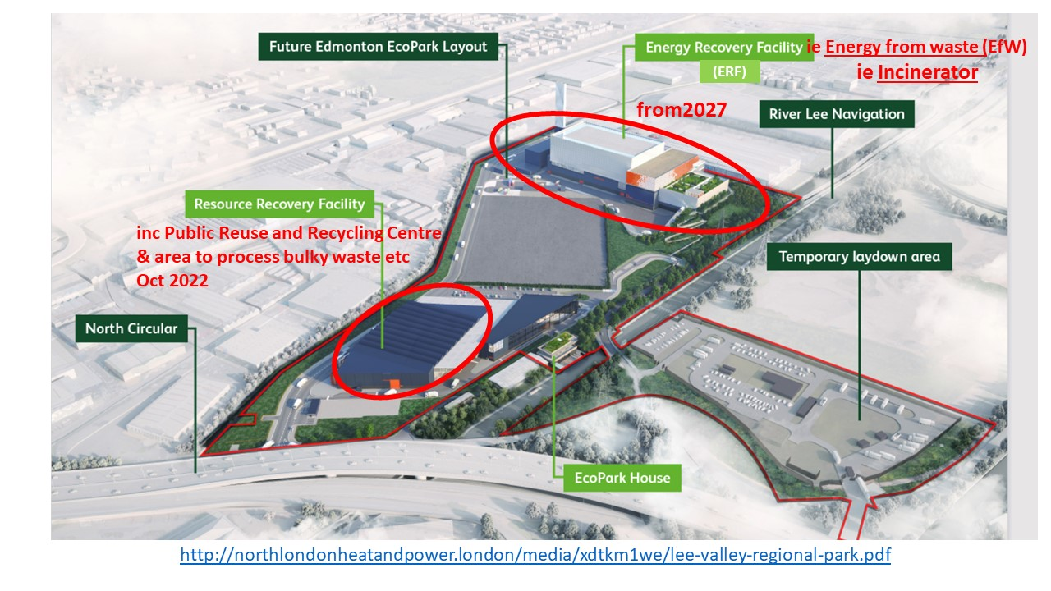

CAPACITY
Current situation and plan
- The figure of 700,000 tonnes residual waste to incinerate at Edmonton’s Energy from Waste (EfW) facility from the start date of 2027 comes from the 2014 Eunomia study (p53), based on figures from the 2014 London Plan, though heavily caveated.
- The NLWA Finance Update 2020/21 (p4) showed a reduction in residual waste to 570,394 tonnes, whereas the Eunomia study relied on steadily increasing waste and low levels of recycling and was written prior to the Government promises to clean up the waste industry.
- The EfW design is for two treatment streams of 350,000 tonnes each, so feedstock from further afield would therefore need to be bought in from time to time to keep these in full use.
- The 2020 London Plan (p371) estimated the total waste from the North London seven Boroughs as 1,796,000 tonnes in 2021 and 1,906,000 tonnes by 2041. However, these figures also included volumes of recycling and commercial and Industrial waste not collected by LAs.
Changes since 2016 affecting capacity

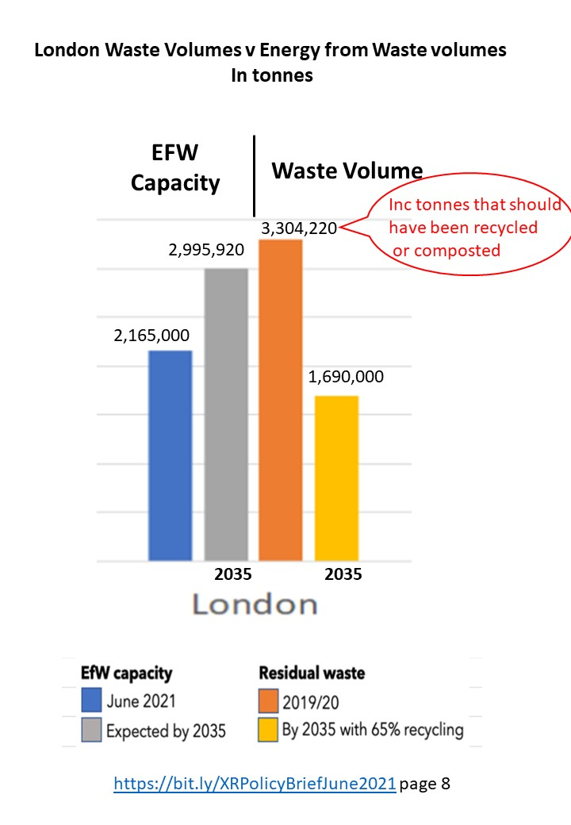 | - Overcapacity across London is estimated as 1,394,080 tonnes by 2035 (2,995.920 cap – 1,690,000 vol) in XRZerowaste’s Policy Brief (p8) based on the 65% recycling target.  - Since more incinerators have been approved in London eg 800,000 tonnes at Cory the GLA have confirmed that they believe that overcapacity could reach 950,000 tonnes.  - Overcapacity across England is estimated in XRZerowaste Policy Brief (p8) as 14,797,270 tonnes by 2035 (27,042,770 cap – 12,245,500 vol) IF Government proposals re waste are implemented  (the XRZero Waste policy brief uses Defra Waste Data Flow https://www.wastedataflow.org/ )
- New Legislation will change the modelling assumptions on residual waste volume and carbon content. The Environment Bill, the Deposit Return Scheme, Extended Producer scheme and Consistency in Recycling will significantly reduce: excess packaging, drinks containers in kerbside collections, food and garden waste in residual collections and volume of contaminated recycling loads. Additional items, such as foil and plastic film will be collected with recycling.
- Payments from packaging producers to Local Authorities, estimated by Defra as around £3m a year will be in place to be used for better recycling handling.
- The London Plan Policy SI 7 has increased the target for recycling from 50% to 65%.
- Above average incineration rates have been shown to be corelated with lower recycling rates, reported from DEFRA data on waste collected by 123 local authorities.
- Landfill can no longer be presented as the only alternative to incineration, as better alternatives become available.
- Proven technologies which extract a) metals, plastic and drinks cartons; b) organics are already in place in Glasgow, Amsterdam, Rotterdam and Oslo, reducing volumes for incineration.
- Emerging technologies which combine mixed waste sorting with mechanical and chemical recycling. to obtain nearly 100% recycling/new fuels/ hydrocarbons. For instance, as a world’s first, Renasci in Belgium aims to transform nearly ALL waste into recyclable materials and hydrocarbons feedstock for plastic and fuel. Once up and running this approach would make incinerators obsolete.

NLWA statements relating to capacity
NLWA has ‘Myth Buster statements’ including items about sticking to forecasts; being consistent with Mayor of London’s target and being the only proven, sustainable and cost-effective solution for treating the required volumes of waste. Little supporting evidence is provided, whereas they can all be refuted with sound evidence.

Risks re capacity
- That residual waste from North London Boroughs will have reduced so much, and so much recyclable material will be extracted, that the capacity of the Edmonton incinerator would be excessive.
- That the higher capacity and lower waste volumes across England would make it difficult to buy in waste
- That having two large treatment streams would not allow the flexibility to match capacity with waste.
- That Energy from Waste incineration will be an obsolete technology soon after Edmonton is commissioned.
Recommended area to reassess
- Capacity. Modelling to cover waste volumes, latest processing options, end product opportunities
- Currently available technology for separation from residual waste
- Emerging technology for integrated residual waste sorting with mechanical and chemical recycling
- Market demand and income for selling sorted wastes, given changes in regulations, technology and market

