High level Briefing for councillors re the plans for the Edmonton Incinerator - Emissions
This is part of a series of briefing papers for decision makers covering Capacity, Emissions and Costs and Ownership with recommendations to reassess the aspects of the plan that have been subject to change. S Charles 25/07/21
Introduction
There have been significant policy and technology changes since the new incinerator proposals were originally formulated. These include: demand versus forecast capacity /recycling polices/ waste separation technology/ low carbon polices and new technologies. There is a window of opportunity to adjust to these changes to future-proof the cost effectiveness, viability and sustainability of North London waste handling.

Scene Setting
The plan was approved by the Planning Inspectorate in 2017 for the redevelopment of the Edmonton site to serve the seven North London Boroughs who jointly own NLWA and its assets. NLWA commissioned the North London Heat and Power Project (NLHPP) to deliver the transformation of the site, concluding with an Energy Recovery Facility, also known as Energy from Waste (EfW) with an incinerator capacity of 700,000 tonnes of waste, due to be contracted by early 2022 and commissioned by 2027.

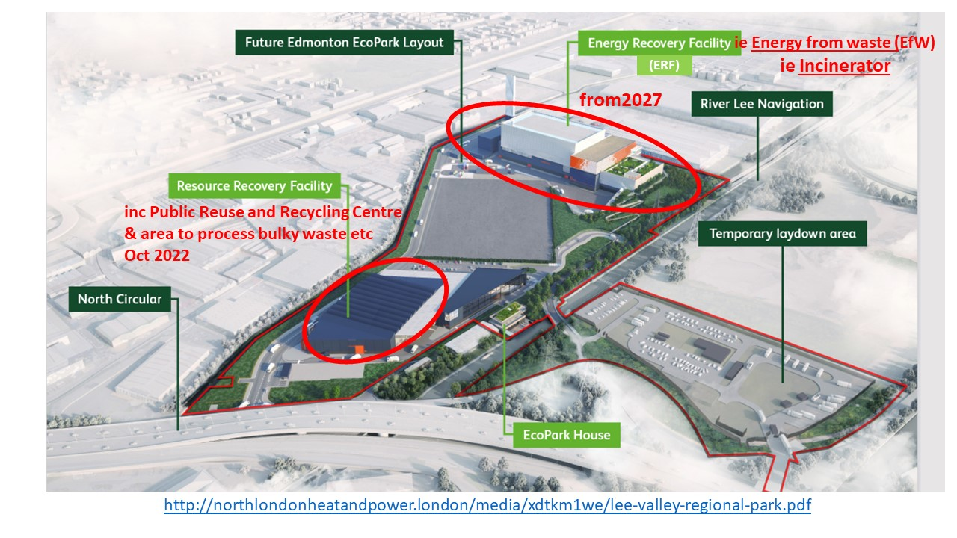
------------------------------------------------------------------------------------------------------------
EMISSIONS – CO₂ and Pollutants
Current situation and plan - carbon emissions from the electricity and heat
- Burning residual waste consisting of plastic (from fossil fuels) and biogenic matter (which will have sequestered some carbon during growth) results in a variable amount of emission of CO2 per tonne.
- The emissions from food and garden waste are not counted in the NLWA calculations. The IPCC (p7) says that these can be discounted from some reporting. Though this should be provided for information. it has not been included in NLWA calculations.

- Actual emission data has been collected by UKWIN in the 2021 Incinerator GHG Guide and this graph shows how high the emissions are compared with low carbon sources of electricity.

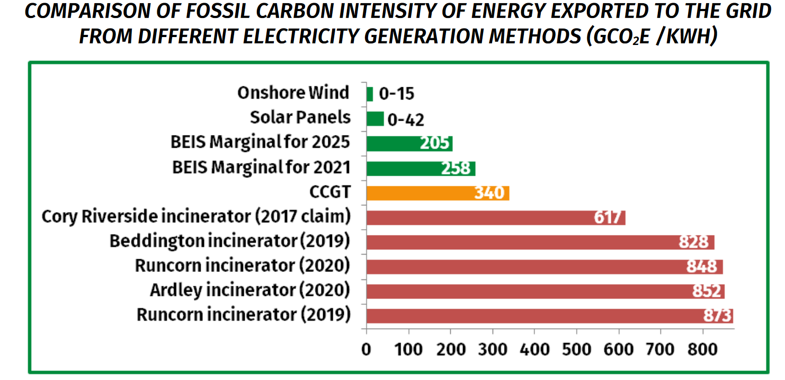
- The UK Emission Trading Scheme has exempted carbon from Energy from Waste despite the emissions per tonne being so much higher than other sources of electricity. Thus the financial case does not reflect the cost of carbon regarding climate damage.
- The carbon intensity of the UK Grid, used for carbon calculations in the plan is 214 CO2e/kWh over the lifetime of the project, whereas it decreases as renewable sources increase. My Grid GB records 220 gm/kWh in 2020.
- The heat calculations use the high (CCGT) carbon intensity as the alternative to heat from the incinerator. instead of using the latest low carbon heat technology with latest predicted electricity carbon intensity.
Changes since 2016 on Greenhouse Gases (GHG - ie carbon equivalents)
- The volume of Energy from Waste should reduce from 5.5 MtCO2e in 2019 to 0.04MtCO2e in 2050 as recommended by the Committee on Climate Change’s 2021 Report to Parliament (p128)
- The carbon intensity of grid supplies should rapidly reduce to 10gm CO2e/kwh by 2035 as recommended by the Committee on Climate Change Sector summary for electricity (p36) compared with the 214gm CO2e/kWh used for the life of the project.
- A Carbon Intensity Floor (CIF) target of 400g CO2e/kwh has been set by the Mayor of London (p314) for electricity generated by incinerators and intends to set a tighter standard of 300g CO2e/kwh by 2030, effectively ruling out “ the use of traditional mass burn incineration techniques generating electricity only.”
- Carbon Capture and Storage (CCS) for all Energy from Waste plants is recommended by the Committee on Climate’s Sector Summary for Waste (p26) with Defra to issue a plan by Spring 2022. Energy from Waste Plants with Carbon Capture May 2020 studies CCS.
- The UK waste industry body ESA is supporting ways to decarbonise waste treatment in Net Zero Exec Summary June 2021.
- New Work on heating in new homes eg Passivhaus and LETI supercede original calculations on District Energy Networks being a low carbon option.

Air Quality and Pollutants
- No Burn Org Pollution and Health Impacts Nov 2019 covers the full scope of pollutants and the disposal paths from collection to disposal of residue.
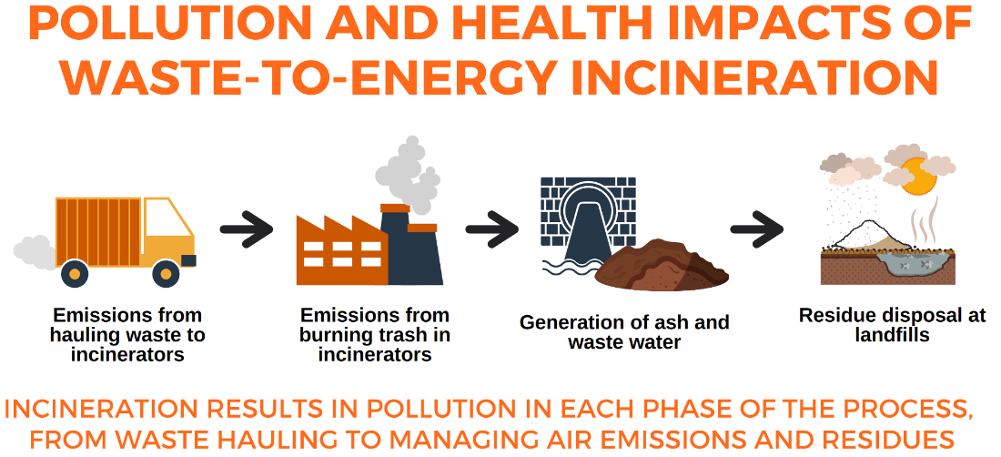
- Defra pollution reporting paper (p 14) lists the pollutants to be reported to the Environment Agency (part of Defra). When the NLWA state that “no concentrations of pollutants will breach any air quality requirements”, they are not considering other pollutants that have not been investigated and may cause ill health to surrounding residents.
- For instance some Ultra Fine Particles (eg PM0.01) and NOx are not captured by filters and escape with gases.
- The reporting regime does not includes PM 0.1 or bottom ash which is the source of micro plastics released into the atmosphere

Changes since 2016 on pollutants
- The Ciel report The Hidden Costs of a Plastic Planet 2019 (p44 says 52) has an up to date explanation of the pollutants from incineration, including the bottom ash poisons from efficient plants - pointing out that incinerators are built in disadvantaged areas
- ZeroWaste Europe reported on a study of the toxins in eggs from chickens around incinerators and discovered that emissions were intermittent, therefore monitoring averages misses pollution events.
- A study in 2016 looked at studied adverse health effects and concluded that further investigation was warranted over a broad groups of congenital anomalies.

NLWA statements v latest information
NLWA’s ‘Myth Buster statements’ include items about being consistent with ambitions set out by the Committee on Climate Change; the NLHPP being a vital part of the solution for tackling the Climate Emergency as well as stressing adherence with only regulated pollutants. Its supporting evidence is provided from a Defra Ultra Fine Particle Study in 2018 with caveats such as “still emit large concentration of UFP forming in the diluting exhaust gases” (p90) that should be followed up now.
.
Risks across carbon and pollutant emissions
- That, if the incinerator provides heat to District Energy Networks the heat will emit more carbon than latest technologies and expected electricity emissions, breaking the UKs Paris pledges and Climate Act targets.
- That living near the incinerator may involve serious health risks.

Recommended area to reassess
- The design needs to have the latest, lowest carbon options, including alternatives to feeding District Energy Networks and maximum recycling before any incineration.
- The health effects on local residents should review the latest research including all pollutants and the sampling and reporting regime should be designed to capture all emissions at every stage.

